
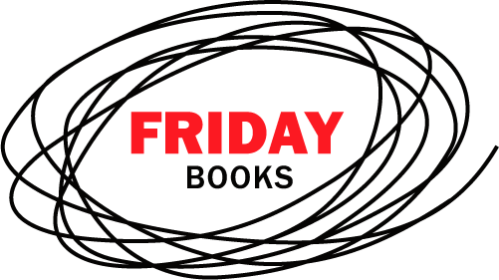
beer in the evening
The Friday Project

Publicity Update: 26 May 2006

National Press:

ES MAGAZINE requested quote from Anne Thorniley for ‘The Next Big Thing’ in William
Sitwell’s Food Spy column, 26 May

GUARDIAN GUIDE requested copy for review

METRO pitched Anne Thorniley for ‘Staying In, Going Out’ slot

EVENING STANDARD Jim Armitage interested in running a
story around London’s best pub,
sent finished copy, has declined

Magazines:

TIME OUT Guy Dimond requested finished copy for review in Food and drink section

THE PUBLICAN will review

TEASER requested for review

FIESTA requested for review

NINE TO FIVE will review

WHAT’S ON IN LONDON review this week with 5-copy reader competition

THIS IS LONDON considering for review

TV/Radio:

XFM: Breakfast offering give-aways on the show and interviewing the author, date tbc

BBC Radio London: Robert Elms interested in interview with Anne

LBC: Weekend Shows producer requested copy for possible
interview

Capital Radio: Johnny Vaughan will keep Anne Thorniley’s details on
file for when they need an expert

Nick Ferrari, LBC has turned down, but will pass onto
other producers

BBC London/London Tonight pitched feature on summer drinking
In the capital

Online:

View London Requested finished copy for
review/feature

London by London running competition

Something for the Weekend
Lastminute.com will feature on the site this week

Other:

Joint launch with Pan Macmillan’s book Three Sheets to the Wind, tbc

