- Play Bar, 58 Old St, London EC1

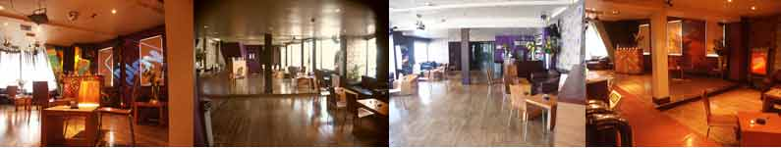

- Living Bar, 443 Coldharbour Lane, London SW9

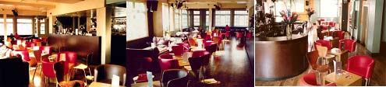

- Mishmash Bar, 45 Lavender Hill, London SW4

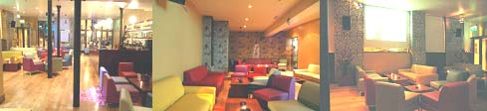

- Nectar Bar, 562 Kings Rd, London SW6

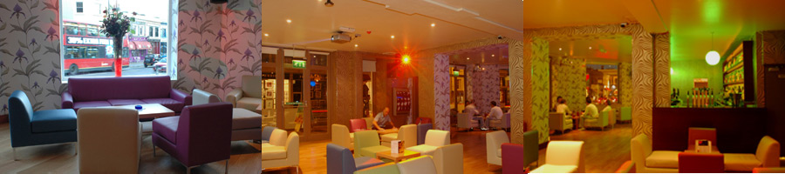

- Precinct Bar, 100 Cromwell Rd London SW7

